# Testing report

Game: **Speed Test the Game** (version of 15.4.2017)  
Date: **15.4.2017**  
Tester: wsd17-atoj-games, <https://gitlab.rd.tut.fi/sepponen/wsd17-atoj-games>  
Game Store version: 15.4.2017, Git commit **a7a879dc**  
Testing methodology:

* Test the game in developer’s perspective. Includes observing game-service communication and game's behavior in its environment.
* Test the game in end user's perspective. Observe game's behavior and interface and reflect it to expectations.

## Technical review

Communication between the game and the service works as intended. Saved data, settings and errors are communicated properly. However, there is a visual bug when loading a save with custom key bindings.

After loading saved game, the key icons, shown in picture below, revert to default V, B, N, M, K configuration.

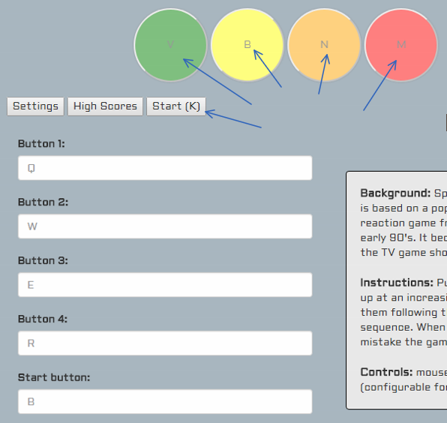

Custom key bindings do work, regardless of this visual bug. The settings menu displays the right key bindings.

## End user’s perspective

Game’s interface is clear and pleasant to look at. Also, the instructions tell all the relevant information to play the game. These things make the game is very approachable. One improvement would be to add some indicator or instruction on when progress is saved. In this game’s case saving is automatic and there could be a mention about it in game.